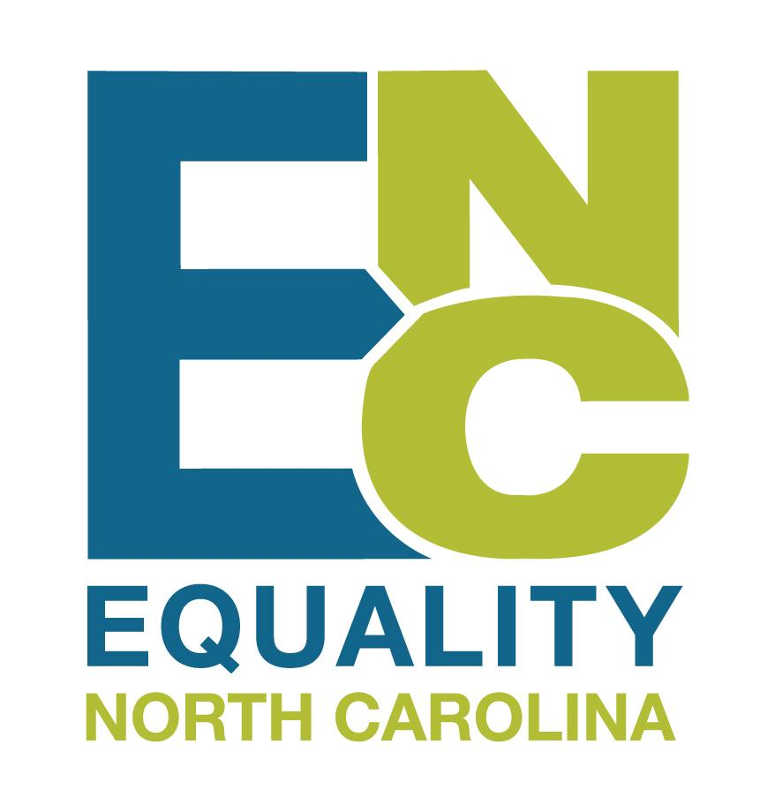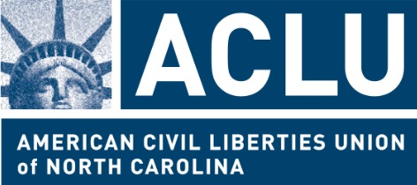

Understanding Gender Marker Updates at NC DMV

In the past you may have been asked by a DMV examiner to present a letter from a physician attesting that you have had “sex reassignment surgery” in order to change the gender marker on your driver’s license.

This year, NC DMV has updated their procedures so that a physician’s letter regarding surgery is no longer necessary.

Instead, all you need is DMV’s new Sex Designation Form signed by you and one of the listed healthcare providers or social service providers, for example, a caseworker or social worker, attesting to your gender identity.

The form DL-300 is available at this link: www.ncdot.gov/dmv/downloads/Documents/DL-300.pdf

You will have to surrender your old ID, have a new photo taken at DMV, and pay the fees for a driver’s license.

Frequently Asked Questions

Q: Will DMV be able to ask me questions about my private medical history or any other gender-related questions when I submit the Sex Designation Form?
A: No, DMV examiners are not supposed to ask anything beyond the information on the form. If a DMV examiner asks you questions about your gender or private medical history when you submit the form, please let Equality NC know by calling 919-829-5699.

Q: What will DMV do with the information on this form?
A: They will scan the form in to their “Customer Tracking Record,” then return the form to you.

Q: Will DMV keep my information on this form private?
A: Yes, DMV is obligated by law to keep this information private under the Driver Privacy Protection Act.

Q: Can I change my name at the same time?
A: Yes, but you will need to complete a separate name change form in order to change your name on your driver’s license. You can do that before or after or at the same time that you submit the Sex Designation Form. Along with the name change form you will need to submit documentation of your legal name change, such as your court order approving your name change.

Q: Do I have to have my information updated with Social Security Administration (SSA) first?
A: If you are changing your name, you must update your legal name with the Social Security Administration first. If you are updating your gender marker, you are not required to change your gender marker on any other forms of identification, and DMV is training its examiners on this point. If DMV tells you otherwise, please let Equality NC know by calling 919-829-5699. Please see www.transequality.org/documents for more information about changing your name and/or gender marker with federal agencies like SSA or Passport Control.

Q: If I have already updated the gender marker on my passport or birth certificate, or if I already have a court order about my gender, do I still need to complete the Sex Designation form?
A: No, the form is not necessary if you have one of those documents that you can bring to the DMV office. The DMV examiner should accept any form of passport documentation, either a passport booklet or a passport card.

Q: Will changing my gender marker on my ID affect my access to healthcare?
A: It should not. It is illegal for insurance companies to discriminate on the basis of sex, which includes denying medically necessary care for your body when that care does not ‘match’ the gender listed on your ID. If you receive a denial of care based on the gender marker on your ID, work with your healthcare provider to re-code and re-submit the claim.

Q: Is there an age requirement for changing the gender marker with the DMV?
A: No. Anyone who is eligible for a permit, license, or state identification card from the DMV may change their gender marker, as long as you have a provider who is willing to sign the form.

